11.22: From Eq. (11.10),
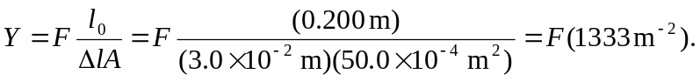
Then, 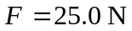 corresponds to a Young’s modulus of 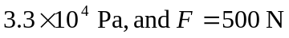 corresponds to a Young’s modulus of 